**Digital Temperature Sensors TC72**

**SPI configuration**

All the transmissions (Write/Read) are made using SPI.

Initialize SPI before start the communication with the TC 72 - Digital Temperature Sensor with SPI Interface.

* *void init_spi_temperature_sensor(void).*

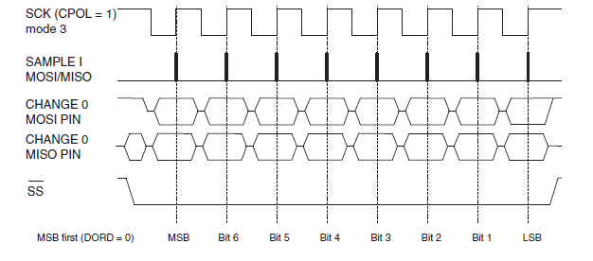

SPI pins on port B: MISO, MOSI, SCK, SS

PB1 = MISO as output

PB2 = CLK as output

PB0 = SS = as output HI

PB3 = MISO as pull up

SPI configuration

Master

MSB first

Load when clock is falling

Sample when clock is raising

To write into the SPI register, must be wrote a Dummy value “0x00” into the SPDR (SPI data register) to start the SPI shift clock and get the values from the temperature sensor.

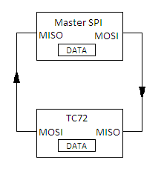

**TC 72**

***Digital Temperature Sensor with SPI Interface.***

PK5 is the EC “Enabler” in the temperature sensor, must be HI to any operation with the TC72.

* *void init_temperature_sensor_oneshot(void)*

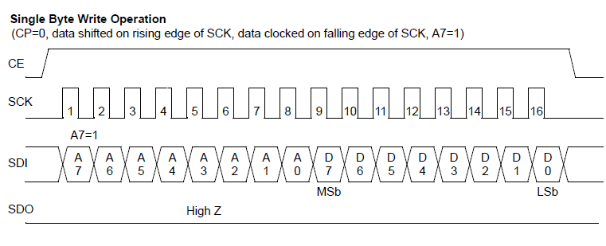

Use every time that you want to read the temperature; the sensor goes to Idle when finish the measurement.

Go into write mode:

*Write 0x80*

Write into the status register:

*Write 0x10 (One shot mode on, shotdown mode off)*

* *int read_temperature(void);* return (int) ((MSB << 2) | (LSB >> 6));

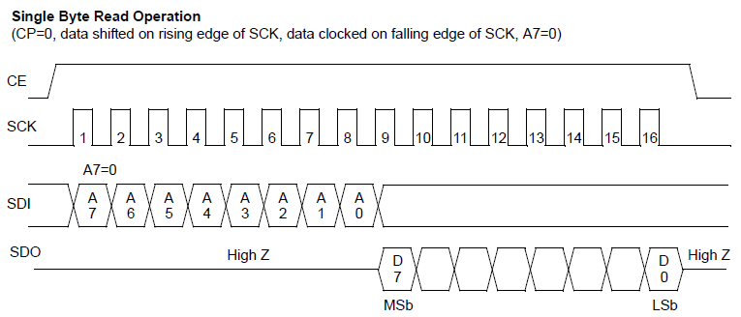

Go to read mode in temperature register 0x01 (LSB register):

*Write 0x01*

Read the 8 bit vector (must write the Dummy value)

*Read LSB*

Go to read mode in temperature register 0x02 (MSB register):

*Write 0x02*

Read the 8 bit vector (must write the Dummy value)

*Read MSB*

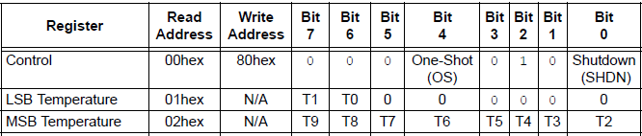

Rearranging the temperature vectors; *int read_temperature(void); return the next number:*

**